Step-by-Step: Booking an Order

| May-20 |

**Document Overview**

**Documentation Goals**

This documentation is intended to provide step by step instructions for ***Booking, Releasing, Posting Bills of Lading, and Invoicing new orders****.*

**Table of Contents**

**Booking an Order** 2

Add an Order 2

Release an Item 6

Find the Release 9

Print Pick Ticket 12

Post Pick Ticket 14

Locate Bill of Lading 15

Post Bill of Lading 17

Locate Invoice 18

Print Invoice 19

Post Invoice 20

# **Booking an Order**

## Add an Order

### Step One: Open Order Maintenance Screen

The *Order Maintenance* screen is located in the following Menu Path: Order Processing -> Update/Add Orders -> Order Entry. Alternatively, the user can quickly get to this screen using the Hot Key combination: ***[“O” – “U” – “1”]***.

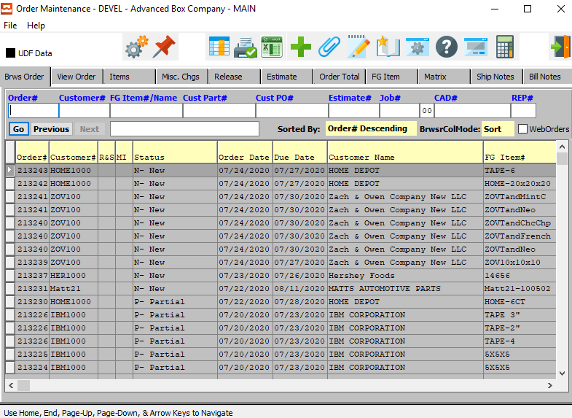

### Step Two: Add a New Order

To add a new order, the user can quickly press the ***“Green + Icon”*** at the top to the screen.



Alternatively, the user can move to the *View Order* tab, and click the ***“Add”*** button at the bottom of the screen.

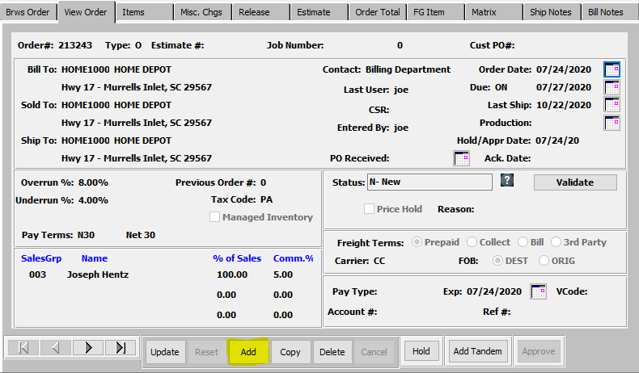

The new order will automatically be given an Order Number by the system, which is not modifiable by the user here.



### Step Three: Enter Estimate

The user must now enter an Estimate Number to base this new order on. If the user knows the Estimate Number that they wish to use, they may enter it manually in the *Estimate #* field.



Alternatively, the user can press the ***“F1”*** key to choose a number from a list of available Estimate Information.

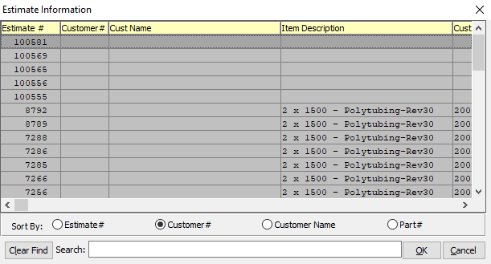

This list can be sorted by Estimate Number, Customer Number, Customer Name, or Part Number. Alternatively, the user may search for any estimate that they wish to use in order to narrow down their selection.

In order to choose the desired Estimate from this list, the user may double-click on the desired Estimate line. Alternatively, the user may click on their desired Estimate Line in order to highlight it within the list, then click the ***“OK”*** button at the bottom of the *Estimate Information* screen. Only a highlighted Estimate will populate within the new order.

### Step Four: Verify Order Information

Once the user has entered or chosen a valid Estimate Number, all of that Estimate’s relevant information will populate within the Order fields.

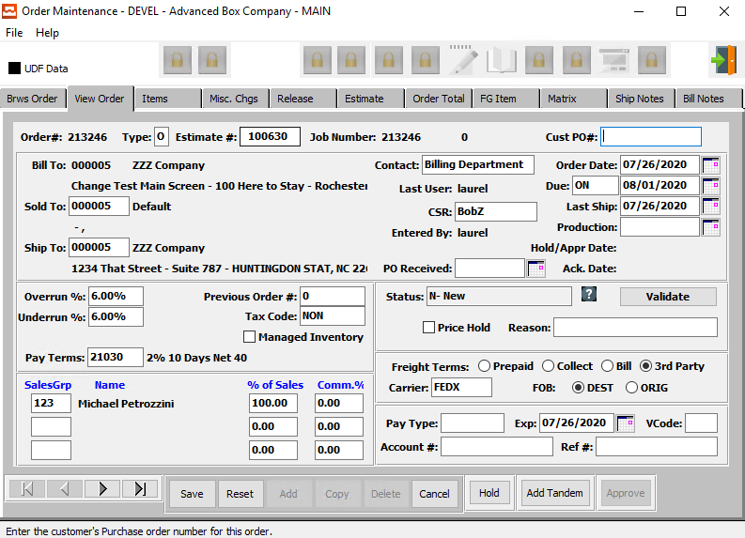

The user may now take this opportunity to update or change any available Order Fields. For any questions concerning specific Order Fields, the user may refer to the ***“Order Processing Manual”***.

### Step Five: Save Order

Once the user is satisfied with all of the information within this new order, they may click the ***“Save”*** button at the bottom of the screen to save the order to the system.



## Release an Item

### Step One: Find Order

If the user is coming back to this new order at a later time, or releasing items from a previous order, they must first find the correct order. To do this, the user must go back to the *Order Maintenance* screen, which is located in the following Menu Path: Order Processing -> Update/Add Orders -> Order Entry. Alternatively, the user can quickly get to this screen using the Hot Key combination: ***[“O” – “U” – “1”]***.



On the *Browse Order* tab, which is the first to open, the user may search for the order from the list of browsable orders. The user may use any of the search fields at the top of the *Browse* screen in order to narrow down their search list.

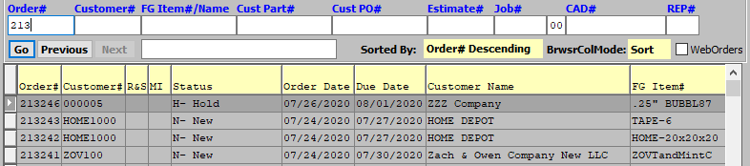

Once the user has found their desired Order, they may click on it in order to highlight it in the list. The highlighted order will populate the other system tabs so that the user may review or update the detailed information for the order.

### Step Two: Go to the *Items* Tab

With the desired order highlighted in the *Browse* screen, the user may click on the *Items* tab in order to view detailed information about the item(s) within this order.

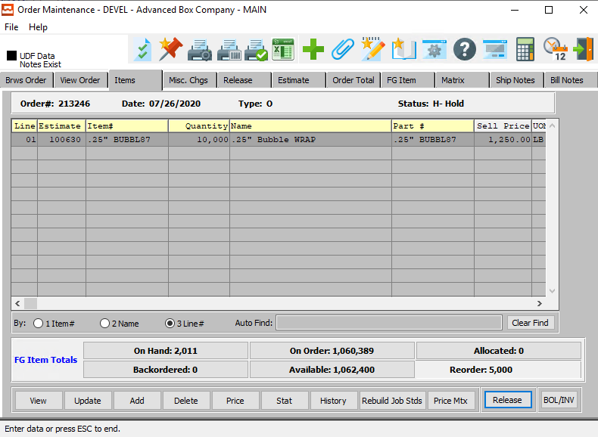

On this screen, the user may update the currently selected item by clicking the ***“Update”*** button at the bottom of the screen. They may also add or delete items from the order on this tab as desired.



### Step Three: Release Item

In order to release an item within an order, the user must first make sure that the desired item is highlighted within the list of items. Only highlighted items will be affected, and the user can only select one item at a time.

The user may click the ***“Release”*** button on the bottom of the screen to create a release for the currently selected item.



The user may then be prompted with a multi-question popup screen. This will be asked of the user if there is an item within the order that is connected to an estimate that was copied to the current order from an existing customer estimate.

First, it will ask the user if they wish to merge all of the items within the order. If the user wishes to do so, they must ensure that the *Prompt to merge each item* toggle box is checked.

The popup screen will also ask the user if they wish to merge items within this order with a previously existing release. If the user wishes to merge these items, they must ensure that the *Merge items with existing release* toggle box is checked.

Once the user has answered these questions, either by checking or unchecking the two toggle boxes, they may answer they main question of this popup box. If the user wishes to create a release and a Ship ID for this item, they may click the ***“Yes”*** button at the bottom of the popup screen.

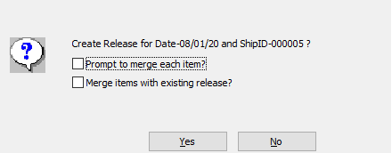

Once the user has decided to release the item(s), they will be asked if they wish to select bins and tags for the release.

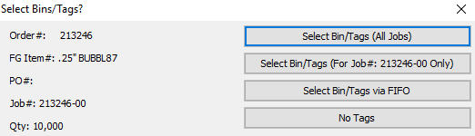

If the user wishes not to select tags here, they may click the ***“No Tags”*** button. This will release the item without any further prompts to the user at this time.

## Find the Release

### Step One: Open Order Release Screen

The *Order Release* screen is located in the following Menu Path: Order Processing -> Tickets for Releases -> Enter/Edit Releases. Alternatively, the user can quickly get to this screen using the Hot Key combination: ***[“O” – “T” – “1”]***.

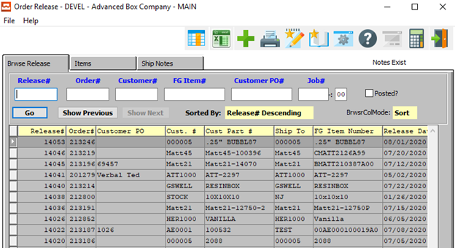

### Step Two: Find Release

On the *Browse Release* tab, which is the first to open, the user may search for the release from the list of browsable releases. The user may use any of the search fields at the top of the *Browse* screen in order to narrow down their search list.

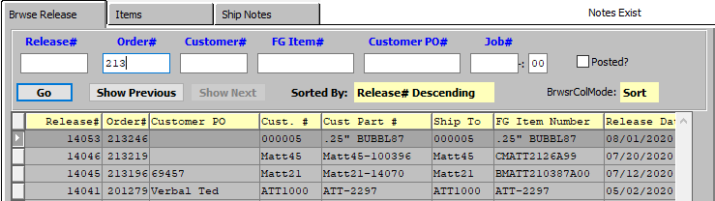

Once the user has found their desired Release, they may click on it in order to highlight it in the list. The highlighted release will populate the other system tabs so that the user may review or update the detailed information for the release.

### Step Three: Go to the *Items* Tab

With the desired release highlighted in the *Browse* screen, the user may click on the *Items* tab in order to view detailed information about the item(s) within this release.

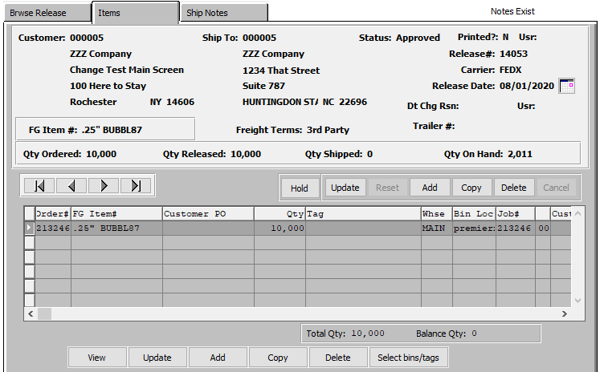

On this screen, the user may update the currently selected item by clicking the ***“Update”*** button at the bottom of the screen. They may also add or delete items from the release on this tab as desired.

### Step Four: Select Bins/Tags

The user may click the ***“Select Bins/Tags”*** button at the bottom of the screen in order to select the bins and tags for the highlighted item on the release.



The user will then be prompted to verify if they wish to select bins for all jobs via a popup screen. Click the ***“Yes”*** button in order to do so.

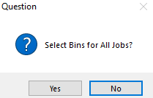

The user may now select which bins they wish to pull the item inventory from. This will make sure that inventory is pulled from the correct location.

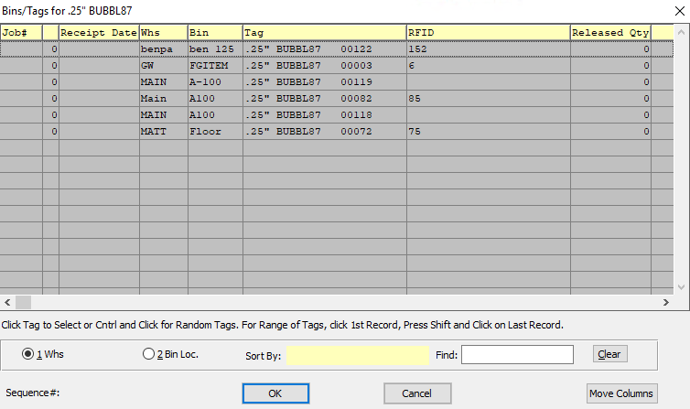

The user may select multiple bins by using the ***“Control-Click”*** method to highlight multiple bins within the list of those available. Only those bins that are highlighted by the user will be used for this release.

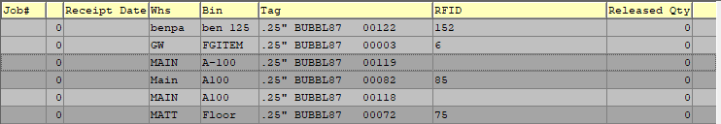

Once the user has selected their desired bins for this release, the release will update the item lines, the total quantity on the release, and the balance quantity of the order.

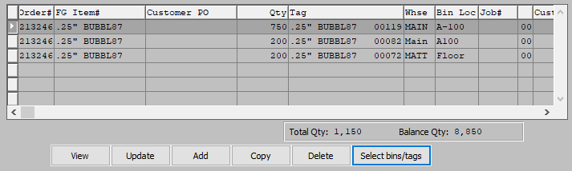

## Print Pick Ticket

### Step One: Open Release Ticket Screen

The *Release Ticket* screen is located in the following Menu Path: Order Processing -> Tickets for Releases -> Print Release Tickets. Alternatively, the user can quickly get to this screen using the Hot Key combination: ***[“O” – “T” – “3”]***.

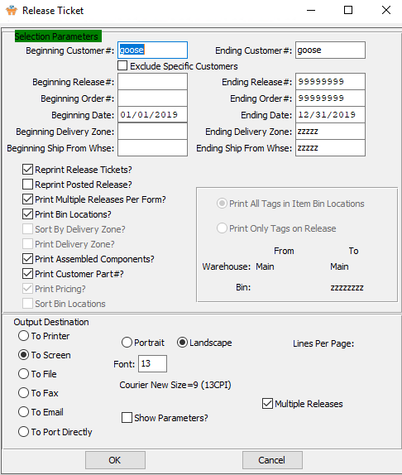

### Step Two: Print Selected Order/Release

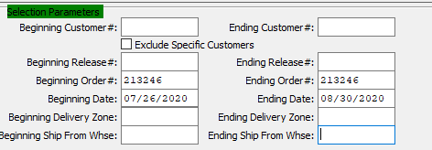

The user may now input their selection parameters as to which orders or releases they wish to print. Multiple release tickets can be printed at the same time, as the user can enter the beginning and ending selections into their desired fields. Releases within those parameters will print tickets.

If the user is attempting to reprint Release Tickets that have previously been printed, they must make sure that the *Reprint Release Tickets* toggle box is checked.

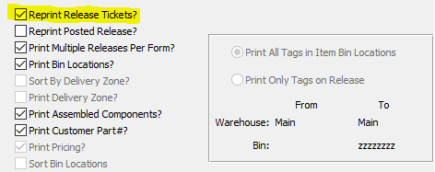

The user may now take this opportunity to check any toggle boxes for other special rules that they with the tickets to follow. For any questions concerning specific rules, the user may refer to the ***“Order Processing Manual”***.

## Post Pick Ticket

### Step One: Open Release Posting Screen

The *Release Posting/Create BOL* screen is located in the following Menu Path: Order Processing -> Tickets for Releases -> Create Bill of Lading. Alternatively, the user can quickly get to this screen using the Hot Key combination: ***[“O” – “T” – “4”]***.

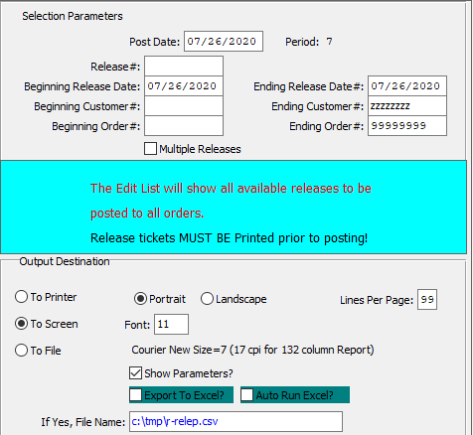

### Step Two: Post Selected Order/Release

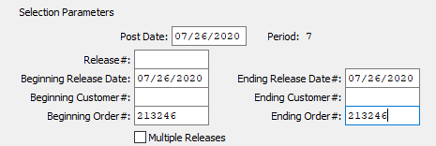

The user may now input their selection parameters as to which orders or releases they wish to post. Multiple release tickets can be posted at the same time, as the user can enter the beginning and ending selections into their desired fields. However, the user must make sure that the *Multiple* Release toggle box is checked in order to do so. Releases within those parameters will post Bills of Lading.

Please Note: Release Tickets must be printed prior to the user attempting to post a Bill of Lading.

## Locate Bill of Lading

### Step One: Open Bill of Lading Screen

The *Bill of Lading Maintenance* screen is located in the following Menu Path: Order Processing -> Shipping/Bill of Lading -> Enter/Edit BOL. Alternatively, the user can quickly get to this screen using the Hot Key combination: ***[“O” – “S” – “1”]***.

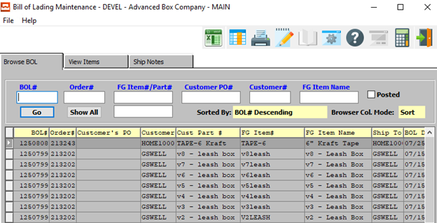

### Step Two: Find Bill of Lading

On the *Browse BOL* tab, which is the first to open, the user may search for the Bill of Lading from the list of browsable BOL’s. The user may use any of the search fields at the top of the *Browse* screen in order to narrow down their search list.

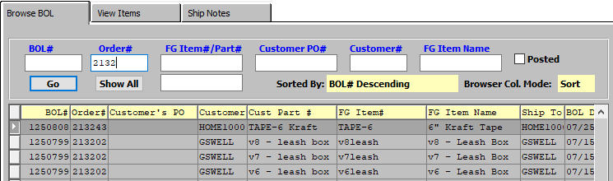

Once the user has found their desired Bill of Lading, they may click on it in order to highlight it in the list. The highlighted BOL will populate the other system tabs so that the user may review or update the detailed information for the Bill of Lading.

### Step Three: Go to the *View Items* Tab

With the desired Bill of Lading highlighted in the *Browse* screen, the user may click on the *View Items* tab in order to view detailed information about the item(s) within this Bill of Lading.

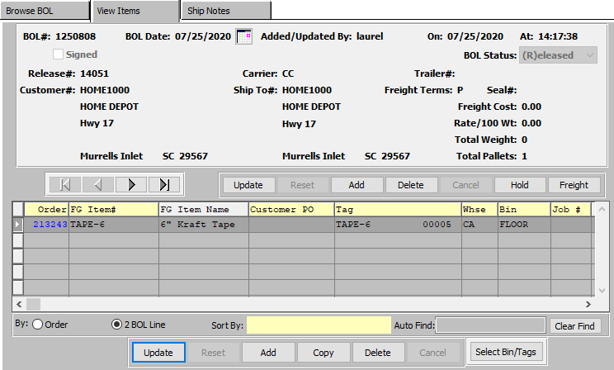

On this screen, the user may update the currently selected item by clicking the ***“Update”*** button at the bottom of the screen. They may also add or delete items from the release on this tab as desired.

The user also has the option to change any information within the main order by clicking the ***“Update”*** button in the middle of the screen, near the main order information area.

Please Note: If the user does make changes to the current Bill of Lading, the order will be placed On-Hold. In order to avoid having to reprint the Bill of Lading, the user can click the ***“Hold/Release”*** button to quickly change the order status.



## Post Bill of Lading

### Step One: Open Release Posting Screen

The *BOL Posting/Create Invoice* screen is located in the following Menu Path: Order Processing -> Shipping/Bill of Lading -> Post BOL/Create Invoice. Alternatively, the user can quickly get to this screen using the Hot Key combination: ***[“O” – “S” – “5”]***.

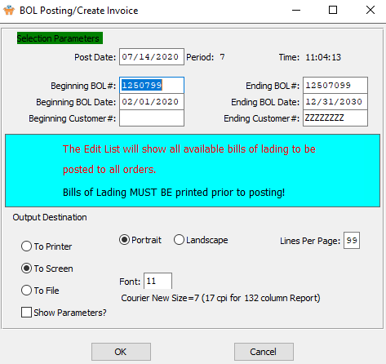

### Step Two: Post Selected Order/Release

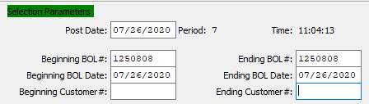

The user may now input their selection parameters as to which bills of lading they wish to post. Multiple BOL’s can be posted at the same time, as the user can enter the beginning and ending selections into their desired fields. Bills of Lading within those parameters will create invoices.

Please Note: Bills of Lading must be printed prior to the user attempting to post.

## Locate Invoice

### Step One: Open Invoice Screen

The *Invoice Maintenance* screen is located in the following Menu Path: Order Processing -> Billing/Counter Sales -> Enter/Edit Invoices. Alternatively, the user can quickly get to this screen using the Hot Key combination: ***[“O” – “B” – “1”]***.

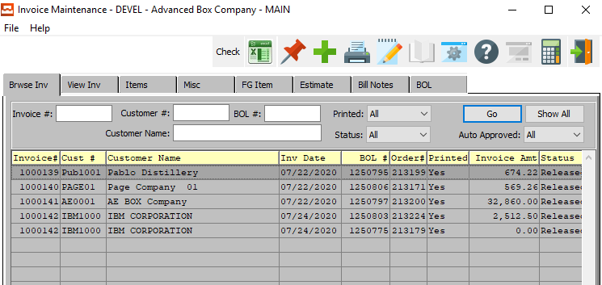

### Step Two: Find Invoice

On the *Browse Invoice* tab, which is the first to open, the user may search for the Invoice from the list of browsable Invoices. The user may use any of the search fields at the top of the *Browse* screen in order to narrow down their search list.

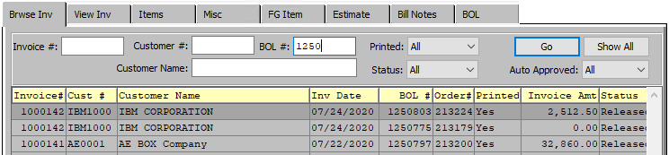

Once the user has found their desired Invoice, they may click on it in order to highlight it in the list. The highlighted invoice will populate the other system tabs so that the user may review or update the detailed information for the invoice.

Please Note: The system does not assign an invoice number until that invoice has been printed.

## Print Invoice

### Step One: Open Invoicing Screen

The *Invoicing* screen is located in the following Menu Path: Order Processing -> Billing/Counter Sales -> Print OE Invoices. Alternatively, the user can quickly get to this screen using the Hot Key combination: ***[“O” – “T” – “3”]***.

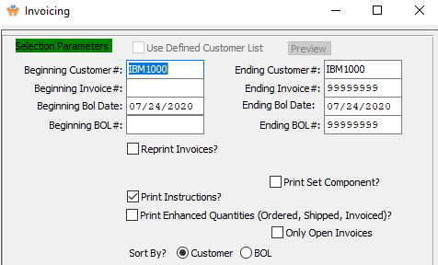

### Step Two: Print Selected Invoice

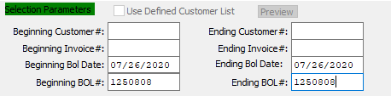

The user may now input their selection parameters as to which orders or releases they wish to print invoices for. Multiple invoices can be printed at the same time, as the user can enter the beginning and ending selections into their desired fields. Invoices within those parameters will print.

If the user is attempting to reprint Invoices that have previously been printed, they must make sure that the *Reprint Invoices* toggle box is checked.

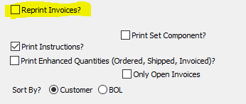

The user may now take this opportunity to check any toggle boxes for other special rules that they with the invoices to follow. For any questions concerning specific rules, the user may refer to the ***“Order Processing Manual”***.

## Post Invoice

### Step One: Open Invoice Posting Screen

The *Invoice Posting* screen is located in the following Menu Path: Order Processing -> Billing/Counter Sales -> Invoice Post/Update GL. Alternatively, the user can quickly get to this screen using the Hot Key combination: ***[“O” – “B” – “4”]***.

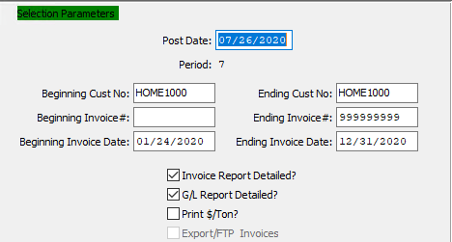

### Step Two: Post Selected Invoice

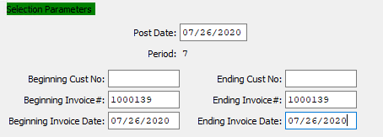

The user may now input their selection parameters as to which invoices they wish to post. Multiple Invoices can be posted at the same time, as the user can enter the beginning and ending selections into their desired fields. Invoices within those parameters will post.

Please Note: Invoices must be printed prior to the user attempting to post. The system will prompt the user to this rule via a popup message when they open the *Invoice Posting* screen.

